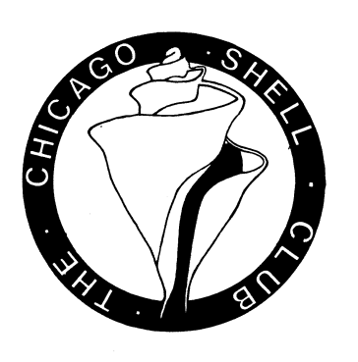
Chicago Shell Club
Announcement
Fossil Collecting Trip
Date: Sunday, October10, 2010
Time: 11:00 A.M.
Place: Racine Quarry Lake Park, North Western Ave (SR-38), Racine, Wisconsin.
Silurian Racine Formation(~420 million years old)
Potential fossils: Crinoid stems (columnals and a chance for some calices), Gastropods, Cephalopods (orthoconic nautiloids) and Trilobites.

Directions: Take the E. Washington Ave (SR-20) exit off I-94, head E. until you reach Green Bay Rd (SR-31), turn left (north) onto Green Bay Rd, shortly after junction with County Road C, Green Bay Rd splits off to the right continue until junction with Northwestern Ave (SR-38) turn right (east) and drive for a short distance where you will see the entrance to the Park and turn right into the parking area. (see map below).

