Second site

Time: 1:00 P.M.
Place: Estabrook Park, off Estabrook Parkway, Milwaukee, Wisconsin.
Devonian Milwaukee Formation (Berthelet & Lindwurm members) (~380 million years)
Common fossils: Brachiopods, bryozoans, criniod columnals, nautiloid cephalopods.
Rare fossils: Trilobites, bivalves, fish (placoderm and shark) plates and spines.

Directions: From previous spot head north on I-94 and the continue on to I-43 then take the exit for N Port Washington Rd on the right then turn left (north) and go a short distance until W Hampton Ave, turn right, then take the next right onto Estabrook Parkway the proceed to large parking area just before baseball diamond (see map below).

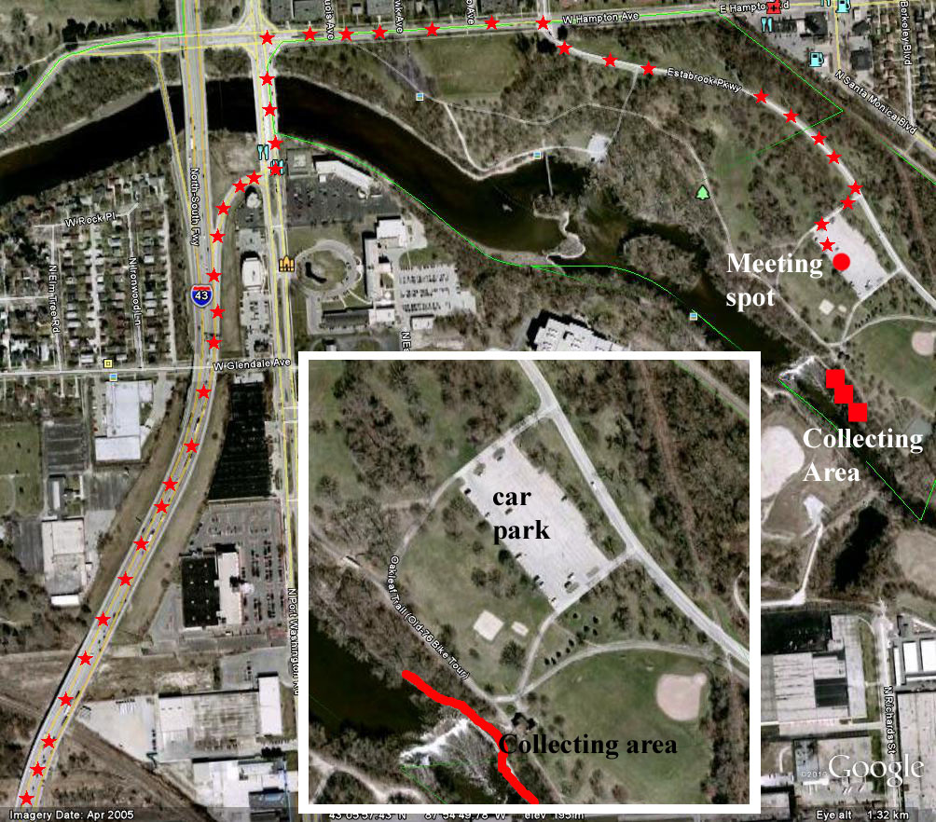

Equipment to bring/helpful: Rock hammer, safety glasses, sample bags, Boots (Estabrook Park outcrop is right along river so can be muddy or flooded).

A restaurant will be chosen that is nearby.

For those that need a ride please or further information contact Jochen Gerber (312) 665 7577 or Stephanie Clark (205) 310 9942

